Shoah Memorial in Guayaquil (photo: December 2010)

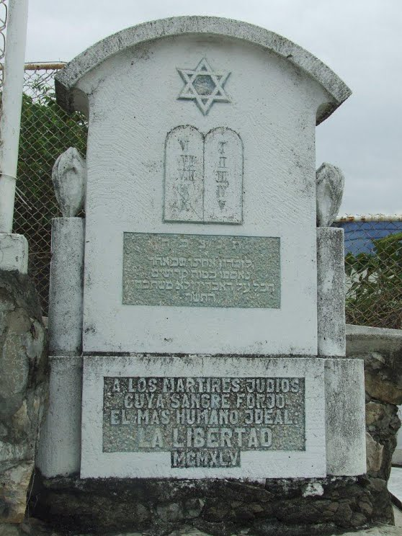

Submitted by Gabriel Alexander

