Shoah Memorial in Quito, September 1943 -- One of the First in the World

Shoah Memorial in Quito, September 1943:
One of the First in the World

Dr. Gabriel E. Alexander

September 25, 2010

On October 16, 1941, Dr. Alfred Karger and his family left Berlin on their way to Ecuador. They were among the last legal Jewish emigrants from the Third Reich; they found refuge in Quito.

Leib Jaffe, director of the Keren HaYesod Head Office in Jerusalem, visited Ecuador in November, 1942. Karger met Jaffe in Quito – an encounter that impressed Karger.

In his letter to Jaffe, dated December 11, 1942, Karger testified that a few days before leaving Berlin he visited Rabbi Leo Baeck. Karger's conversation with Baeck was the main reason for his letter to Jaffe: Baeck had charged Karger with a mission for the Jews in the Free World. In turn, Karger asked Jaffe to tell the world:

"Sagen Sie, sehr verehrter Herr Jaffe, dass das Judentum in Deutschland sich bis zum letzten seiner Verantwortung bewusst ist, dass es trozt alle Bedrueckung, Not und Geiselung versucht, seine juedischen Aufgabe zu erfuellen, geleitet von der Ethik seines philosophischen Praesidenten, Dr. Baeck (...)."

["Tell, honorable Mr. Jaffe, that Jewry in Germany is aware of its responsibility to the last, that despite all oppression, misery, and captivity, that it tries to meet its problem, guided by the ethics of its philosophical president, Dr. Baeck (...)."]

Karger urged Jaffe to tell the Jewish people that according to the philosophic ethics of Rabbi Leo Baeck, Jews in Germany continue to uphold their Jewish responsibilities despite the oppression, repression, and captivity. From later statements in his letter, it is apparent that Karger knew well that those Jews who were imprisoned in concentration camps could expect nothing else other than death.

Together with Quito’s Jewish leaders, Dr. Alfred Karger inaugurated the Jewish cemetery in La Magdalena, Quito, on September 5, 1943. It was a memorial to the victims of the racial and religious persecutions of the Nazi regime in Europe. The ceremony was reported by Ecuador’s newspapers and radio stations. See copies below. Among those who attended was a representative of the President of Ecuador. At the conclusion, Ecuador’s national anthem, “Salve, Oh Patria” was sung in Spanish, and “Hatikvah” in Hebrew.

Karger's letter is a historical document of great importance. It is a testimony of the tragic fate of European Jewry, and, particularly, German Jewry, and is significant due to two factors:
a. It was written in "real time" when nobody knew how and when World War II would end.

b. It was written in the "free world" by someone who was privileged to leave the Third Reich's "jailhouse" legally, had connections with Berlin’s Jewry, and knew well about events unfolding there at the time.

As far as my professional knowledge goes, the memorial that Quito's Jewry erected in September,1943, a few days before the High Holidays, must be one of the first of its kind: a specific commemoration to the victims of the Holocaust – and probably the first in the world.

Sources:

−−€Walter Karger's recollections, "Immigrating to Ecuador” – Jews of Ecuador Web site.
−−− €Alfred Karger’s letter to Leib Jaffe, dated December 11, 1942. Kept in file KH4B/1310, Central Zionist Archives, Jerusalem.
-- Newspaper clipping file, temporary number 11, in Beneficencia Israelita Quito Archives, Central Archives for the History of the Jewish People, Jerusalem.
-- John Fried photo collection, Jews of Ecuador Web site.

Dr. Gabriel E. Alexander
20 Hatibonim St., IL-92386 Jerusalem, Israel
Postal address: P.O.Box 7229, IL-91071 Jerusalem, Israel
Tel: Home 972-2-5618166 Cellular: 972-52-4662369 Fax: 972-72-2829296
e-mail: gabi2022@012.net.il or eitan2022@gmail.com

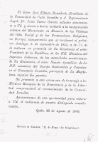

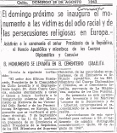

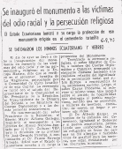

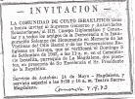

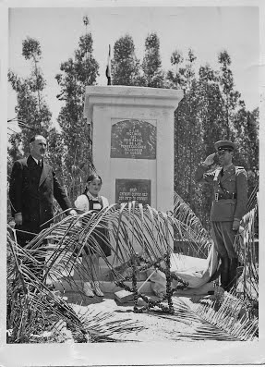

Original Holocaust Memorial, in Quito's Jewish Cemetery -- 1943 (one of the first of its kind anywhere)

Submitted by Gabriel Alexander

